**Project Design Phase-II**

**Technology Stack (Architecture & Stack)**

|  |  |
| --- | --- |
| Date | 03 October 2022 |
| Team ID | PNT2022TMID02 |
| Project Name | Nutrition Assistant Application |
| Maximum Marks | 4 Marks |

**Technical Architecture:**

The Deliverable shall include the architectural diagram as below and the information as per the table1 & table 2

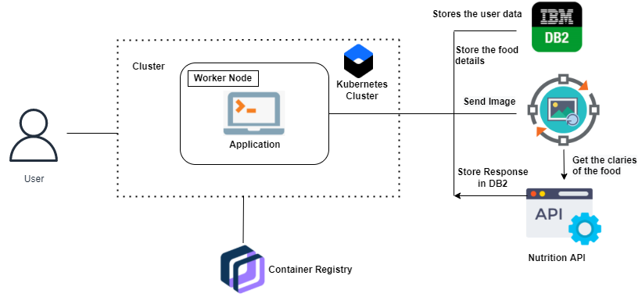

**Table-1 : Components & Technologies:**

|  |  |  |  |
| --- | --- | --- | --- |
| **S.No** | **Component** | **Description** | **Technology** |
| 1. | User Interface | How user interacts with application | JavaScript/HTML/CSS |
| 2. | Application Logic-1 | Logic for a process in the application | Flask |
| 3. | Application Logic-2 | Logic for a process in the application | IBM Cognos |
| 4. | Database | Data Type, Configurations etc. | MySQL, NoSQL, etc. |
| 5. | Cloud Database | Database Service on Cloud | IBM cloud object storage, IBM DB2 |
| 6. | File Storage | File storage requirements | Local Filesystem |
| 7. | Infrastructure (Server / Cloud) | Application Deployment on Local System / Cloud Local Server Configuration:  Cloud Server Configuration : | Local etc. |

**Table-2: Application Characteristics:**

|  |  |  |  |
| --- | --- | --- | --- |
| **S.No** | **Characteristics** | **Description** | **Technology** |
| 1. | Open-Source Frameworks | List the open-source frameworks used | Flask |
| 2. | Security Implementations | List all the security / access controls implemented, use of firewalls etc. | SHA-256 |
| 3. | Scalable Architecture | Justify the scalability of architecture (3 – tier, Micro-services) | 3-tier |
| 4. | Performance | Design consideration for the performance of the application (number of requests per sec, use of Cache, use of CDN’s) etc. | Function/Stateless components used. CSS animations. Memoization of React components |